**Training and Internship at**

**[Directorate of Ordnance (Coordination & Services) Ministry of Defence, Goverment of India](https://en.wikipedia.org/wiki/Directorate_of_Ordnance_(Coordination_&_Services)" \t "https://search.brave.com/_self)**



By

Sreejit Das   
2129141

**Content Page**

|  |  |  |
| --- | --- | --- |
| **Serial no.** | **Content** | **Page-number** |
| **1** | **Expression of Gratitude** | **1** |
| **2** | **Introduction and Overview** | **2** |
| **3** | **Day wise Report on the Internship done on Cyber Security Policies and Web Development** | **3-10** |
| **4** | **Project Gallery** | **11-13** |
| **5** | **Conclusion** | **14** |

**Expression of Gratitude**

During my internship/training, I was guided by the extremely proficient and expert

officers of IT division of DoO(C&S). I am thankful for the whole hearted support and

skillful guidance of the following mentor/Officers:

1. DDG/IT

2. DDG/N&I

3. DD/IT

4. HOS/IT

**Introduction and Overview**

I have worked at the DoO (C&S) for one Month, where I gained invaluable knowledge and improved my skill set significantly. During this time, I developed a deep understanding of cyber-security policies, especially while studying the Ministry of Defense's cyber-security protocols. This experience sharpened my awareness of the importance of securing networks, mitigating threats, and complying with governmental regulations.

Additionally, I worked on creating a fully functional website for guesthouse booking, applying the Model-View-Controller (MVC) framework, which helped me better understand how to structure web applications for scalability and maintainability.

**Day wise Report on the Internship done on Cyber Security Policies and Web Development:**

This day-wise report outlines the activities, learning outcomes, and challenges I faced during my internship at DoO C&S. Each entry provides a comprehensive overview of my daily tasks and the skills I developed. The report reflects my continuous growth as I applied theoretical concepts to real-world scenarios. It also highlights how this experience contributed to my overall professional development.

|  |  |  |  |
| --- | --- | --- | --- |
| Day no. | Overview and Observation | Date | Day |
| 1 | I went to the office for the first time got introduced with the employees and the senior officer I would work under. I was both nervous and excited. For the start I was assigned to make a summery report on the Cyber Security Policy of DoO(C&S). | 15-05-2023 | MON |
| 2 | I was given a Confidential Government Document of Cyber security Policy. I took a overview of that and started making the report | 16-05-2023 | TUE |
| 3 | I learned the theory of cyber security, which consists of three main aspects: the **Aim**, **How it Works**, and its **Scope**. The primary aim of cyber security is to protect organizations from cyber threats by ensuring **Confidentiality**, **Integrity**, and **Availability** of data. In terms of how it works, cyber security involves **Governance**, which aligns security programs with business goals, as well as the use of advanced **Technologies** like AI, encryption, and firewalls to safeguard systems. The **Scope** of cyber security is broad, covering network security, application security, data protection, incident response, and compliance with regulations to mitigate risks effectively. | 17-05-2023 | WED |
| 4 | I studied the **Cyber Security Policy**, which includes key terminology and the specific policies followed by DoO(C&S). Some important terms in cyber security include **Assets**, which refer to valuable resources like data and systems that need protection; **Threats**, which are potential risks that can exploit system vulnerabilities; and **Risk**, which refers to the potential negative impact of these threats.  The **Cyber Security Policies of DoO(C&S)** are aligned with **ISO 27001** and **ISO 27002** standards, ensuring a robust **Information Security Management System (ISMS)**. These policies include maintaining asset safety, protecting mobile devices from unauthorized access, controlling access to sensitive information, and ensuring secure communication systems. Regular audits are conducted to check adherence to these security norms, and a **Cyber Crisis Management Plan (CCMP)** is in place to respond to incidents efficiently. | 18-05-2023 | THU |
| 5 | I also studied **Cyber Security Policy 4** at DoO(C&S), which is aligned with **ISO 27001** and **ISO 27002** standards, ensuring the security of information systems. This policy defines the requirements for an **Information Security Management System (ISMS)** and physical security elements.  The **Hierarchical Structure** for cyber security includes several key roles:  **Local Cyber Security Cell (LCSC):** Responsible for responding to advisories, implementing IT best practices, and conducting intra-factory audits.  **Local Cyber Security Officer (LCSO):** Oversees the LCSC and conducts unit audits.  **Sectoral Cyber Security Cell (SCSC):** Manages organization-wide cyber security programs, directs audits, and provides employee training.  **Chief Information Security Officer (CISO):** Heads the entire cyber security structure, reports progress quarterly, monitors audits, and leads disaster recovery operations.  This hierarchical structure ensures a clear flow of responsibility and oversight, maintaining security and compliance across all units. | 19-05-2023 | FRI |
| 6 | Holiday | 20-05-2023 | SAT |
| 7 | Holiday | 21-05-2023 | SUN |
| 8 | I learned several important points from **Cyber Security Policy 4** at DoO(C&S). The policy emphasizes **Asset Safety**, where asset owners are responsible for the security of all organizational resources. **Mobile Device Safety** ensures that mobile devices are protected from loss and only connect to secure networks. **Access Control** limits system access to authorized personnel, with user privileges regularly reviewed. The policy also includes **Media Management**, where data is encrypted, and unused media is properly disposed of. Finally, regular **Audits** are conducted to ensure compliance with security protocols. | 22-05-2023 | MON |
| 9 | The next day, I went to an associated government officer for help with my demo report and PowerPoint presentation. The officer gave me useful advice that helped me improve my content and presentation skills. Their guidance made me feel more confident and ready for my upcoming tasks. | 23-05-2023 | TUE |
| 10 | I learned about the key **Security Elements** at DoO(C&S).  **Organization Network Security** focuses on protecting both the internet and intranet. The organization maintains an air gap between these networks to ensure that confidential data is kept secure.  **Antivirus** software is installed on all systems to detect and eliminate malware, with regular updates to keep defenses strong against new threats.  **Firewall** systems are in place to filter and monitor network traffic, blocking unauthorized access while allowing legitimate communications.  Finally, the  **Centrally Controlled Domain Controller** manages security and access control for all client computers. It allows administrators to monitor activity, grant access, and block invalid requests effectively. | 24-05-2023 | WED |
| 11 | My project mentor took me to the server room to see the organization’s servers, firewall, and the entire back end hardware system. This visit gave me valuable insights into how the infrastructure supports the organization’s operations and enhances security. Observing the hardware setup and understanding its functions was a great learning experience. | 25-05-2023 | THU |
| 12 | I learned more about Cyber Audit. I gained insights into how audits are conducted to ensure that the organization's security measures are effective and compliant with established policies. Understanding the different types of audits, such as intra-unit, inter-unit, and external audits, helped me appreciate the importance of regular assessments in maintaining a secure environment. | 26-05-2023 | FRI |
| 13 | Holiday | 27-05-2023 | SAT |
| 14 | Holiday | 28-05-2023 | SUN |
| 15 | I learned about the **Cyber Crisis Management Plan (CCMP)**, which provides a structured approach to handling security issues. It defines key terms such as **Cyber Events**, which are observable occurrences in a system.  **Incidents**, which are events that may lead to breaches in information security; and **Crises**, which are severe breaches that require immediate action. I also learned the procedures for when a **high authority** finds a security problem, as they report it to the Chief Information Security Officer (CISO) for coordination.    Similarly, when a **user** discovers a security issue, they report it to the **Local Cyber Security Cell (LCSC)**, which evaluates and escalates the matter as needed.    Additionally, I gained insights into the organization's connections with external government entities like CERT-In, CIRA, CSG DDP,MEITY,which provide support in managing and responding to cyber threats. | 29-05-2023 | MON |
| 16 | I took my reports and insights to the Associate Officer, who provided valuable assistance and helped me make several corrections. With their guidance, the report on Cyber Security was finalized, marking the successful completion of my first task. I felt a sense of accomplishment as I wrapped up this important aspect of my internship | 30-05-2023 | TUE |
| 17 | I was assigned to create a website for booking rooms at a government guesthouse. This project allowed me to apply my knowledge of web development while contributing to the organization. I was excited to take on this challenge and looked forward to designing a user-friendly platform for guests. | 31-05-2023 | WED |
| 18 | I was taught the MVC (Model-View-Controller) framework by my mentor. This framework is a structured approach to web application development that separates an application into three main components: the Model, which handles the database connection and data management; the View, which presents the user interface and interacts with users; and the Controller, which processes user input and communicates between the Model and the View. Understanding this framework is essential for organizing code, improving maintainability, and building scalable web applications, and I found it incredibly useful for my project on the guesthouse booking website. | 01-06-2023 | THU |
| 19 | I began creating the website for guesthouse booking. I started by establishing the folder structure as instructed, ensuring everything was organized. After that, I created the basic files necessary for the project, including index.php, init.php, config.php, rout.php, and framework.php. This foundational work set the stage for developing the website's functionality and layout. | 02-06-2023 | FRI |
| 20 | Holiday | 03-06-2023 | SAT |
| 21 | Holiday | 04-06-2023 | SUN |
| 22 | I began creating the frontend files for the website. During this time, I was also invited to a promotion party for an employee, which was a wonderful experience. It was an honor to sit with my co-workers and the officers at the lunch table, as it gave me a chance to connect with them outside of work. The atmosphere was celebratory, and I appreciated the opportunity to be part of such a significant event. | 05-06-2023 | MON |
| 23 | I completed the basic structure and frontend of the guesthouse booking website. After finalizing the design and layout, I presented it to my mentor for review. I was pleased to receive their approval, which marked an important milestone in my project and boosted my confidence in my web development skills. | 06-06-2023 | TUE |
| 24 | I completed the basic structure and frontend of the guesthouse booking website. I created several view files, including header.php, which includes all the bootstrap functions for styling; home.php, which serves as the homepage; booking.php, where users can submit their room booking requests; approvl_sts.php, where users can check the approval status of their applications; review.php, which displays previous reviews and allows users to submit new ones; and contact.php, which provides contact information for inquiries. After finalizing the design and layout, I presented everything to my mentor for review. I was pleased to receive their approval, marking an important milestone in my project and boosting my confidence in my web development skills. | 07-06-2023 | WED |
| 25 | I learned about the XAMPP server in detail, including how to set it up and use its features. I discovered how to create a database, which is essential for managing data for the guesthouse booking website. This knowledge will be instrumental as I continue to develop the project, allowing me to effectively handle user information and booking records. | 08-06-2023 | THU |
| 26 | I began creating the database in XAMPP. At first, I felt quite confused and ended up designing different structures before settling on one. After selecting a structure, I presented it to my mentor, who provided valuable corrections and guidance. With their help, the database was finalized and ready for use, allowing me to integrate it into the guesthouse booking website. | 09-06-2023 | FRI |
| 27 | Holiday | 10-06-2023 | SAT |
| 28 | Holiday | 11-06-2023 | SUN |
| 29 | I focused on designing the controller.php file for the guesthouse booking website. This file is essential in the MVC framework, as it manages the flow of data between the model and view components. Initially, I found the task quite confusing because it involved defining multiple controller methods to handle various user requests, such as viewing the homepage, processing bookings, and displaying approval status.  Each method needed to effectively link the user input to the appropriate model functions and then render the correct view. I struggled with organizing the code and understanding how to implement the necessary logic. However, with the invaluable help of my mentor and a former officer, I was able to clarify my doubts and gain a better understanding of the structure. They provided insights on best practices and troubleshooting techniques, which guided me through the process. After several iterations and corrections, I successfully completed the controller.php file, ensuring that it would facilitate smooth communication between the website’s components. This accomplishment boosted my confidence and enhanced my understanding of the MVC framework. | 12-06-2023 | MON |
| 30 | I focused on creating the model.php and database.php files for the guesthouse booking website. The model.php file is crucial for handling database interactions, allowing the application to perform operations like adding new bookings, updating records, and retrieving information. Meanwhile, the database.php file is responsible for establishing the connection to the database, defining the necessary credentials, and managing queries. As I developed these files, I ensured they adhered to the MVC structure, which facilitated seamless data handling between the model and controller. Completing these files was an important step in building the website's backend functionality. | 13-06-2023 | TUE |
| 31 | I connected model.php with the database in XAMPP, marking a significant step in completing the guesthouse booking website. While the initial connection seemed successful, I quickly encountered numerous error messages and bugs, which made troubleshooting essential. I realized that I had also updated the basic files along with creating new ones to ensure everything was compatible and functioning properly. Despite the challenges, I was determined to resolve these issues, as they were crucial for the overall functionality of the website. | 14-06-2023 | WED |
| 32 | I went to a higher officer who provided invaluable assistance in troubleshooting the remaining bugs and errors in the project. Their expertise helped me identify and resolve the issues effectively, bringing the guesthouse booking website close to completion. I appreciated their guidance, as it made a significant difference in finalizing the project and ensuring that it functioned smoothly. | 15-06-2023 | THU |
| 33 | I submitted pictures of the guesthouse to be added to the gallery section of the website. With this final touch, the project was complete but still waiting for approval. It was a rewarding experience to see all my hard work come together, and I felt a sense of accomplishment knowing that the guesthouse booking website was ready for review. | 16-06-2023 | FRI |
| 34 | Holiday | 17-06-2023 | SAT |
| 35 | Holiday | 18-06-2023 | SUN |
| 36 | I was pleased to see that all my efforts had paid off, as the website was finally approved by the government officer. With the approval in hand, I began working on my report, documenting the entire process of developing the guesthouse booking website. This was an exciting step, as it allowed me to reflect on my learning experiences and the skills I had gained throughout the internship. | 19-06-2023 | MON |
| 37 | I continued working on the report, detailing the development process of the guesthouse booking website. In addition, I started preparing a presentation that I would present in front of the officers. This presentation was important, as it would allow me to showcase my work and highlight the skills I had acquired during my internship. I focused on organizing my thoughts and ensuring that the key points were clearly communicated. | 20-06-2023 | TUE |
| 38 | This day was doomsday, as I had to present the presentation I had prepared. I approached it with great confidence and was pleased with how it went. I effectively communicated the key points of my project, and I was thrilled to receive appreciation from my co-workers and the officers. Their positive feedback made all the hard work worthwhile, and it was a rewarding conclusion to my internship experience. | 21-06-2023 | WED |
| 39 | My report was approved and signed by the senior officer. During our conversation, he remarked on how much more confident I appeared compared to my first day at the internship. His acknowledgment of my growth and development throughout the experience was incredibly encouraging and served as a reminder of how far I had come during my time at the Directorate of Ordnance. | 22-06-2023 | THU |
| 40 | It was my last day at the office; it was my farewell. It marked the end of my internship, and I took the time to say goodbye to my mentors and colleagues, reflecting on the valuable experiences I gained during my time at the Directorate of Ordnance. | 23-06-2023 | FRI |

**Project Gallery**

**Structure**

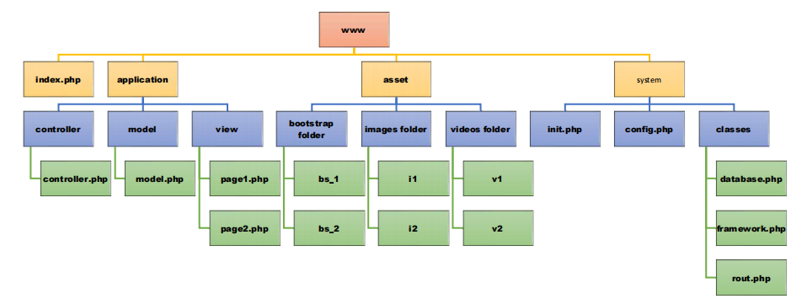

**MVC Framework working**

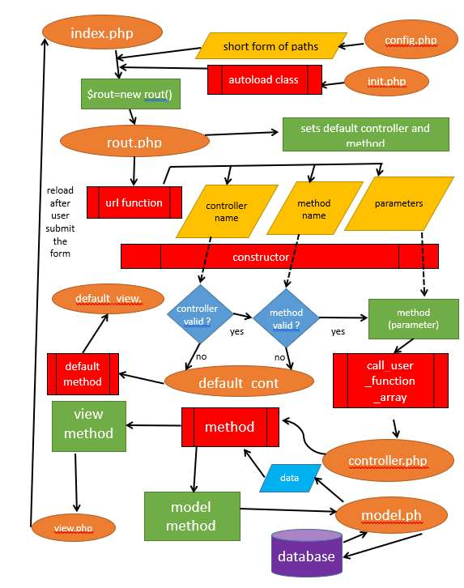

**Project Outputs**

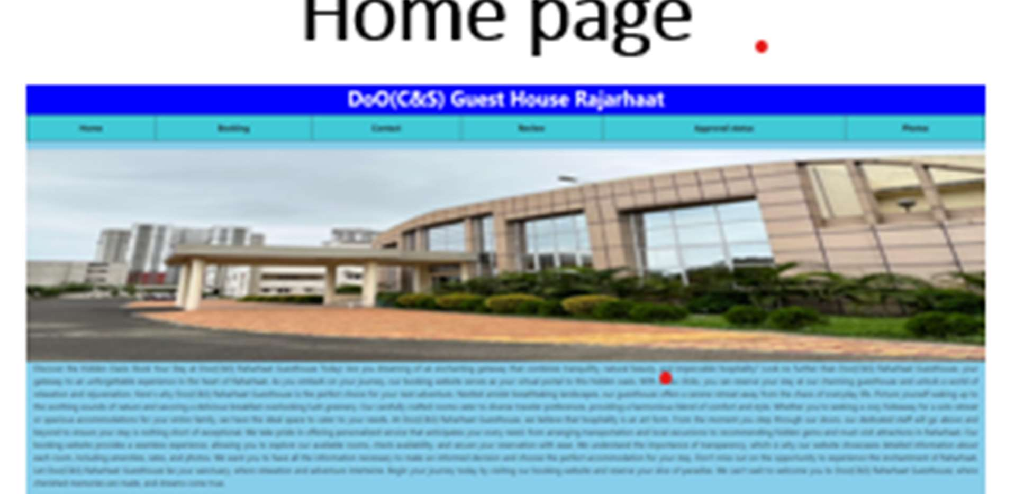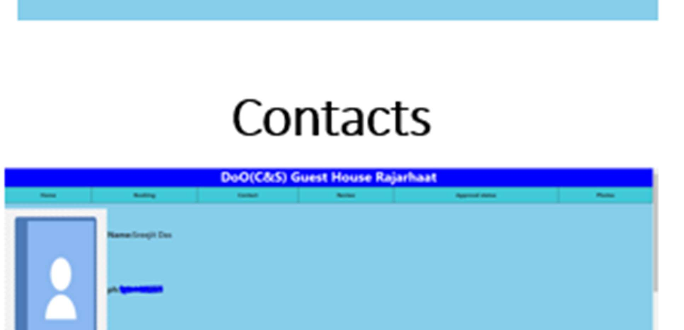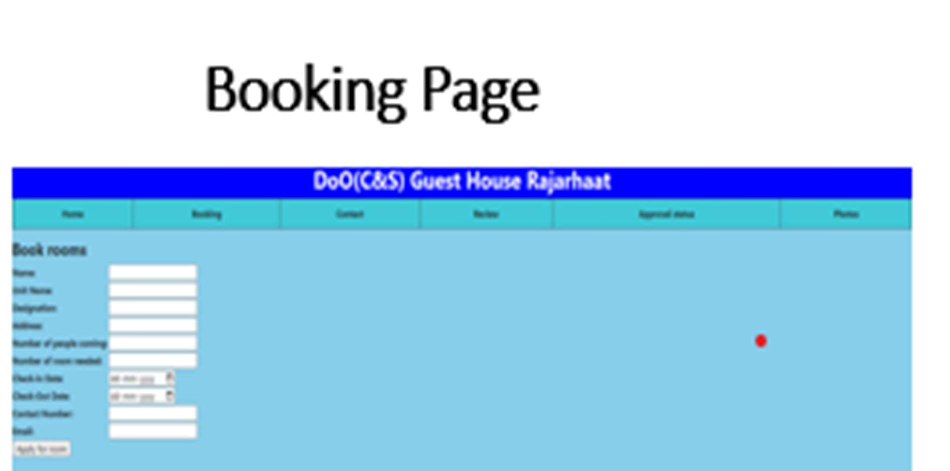



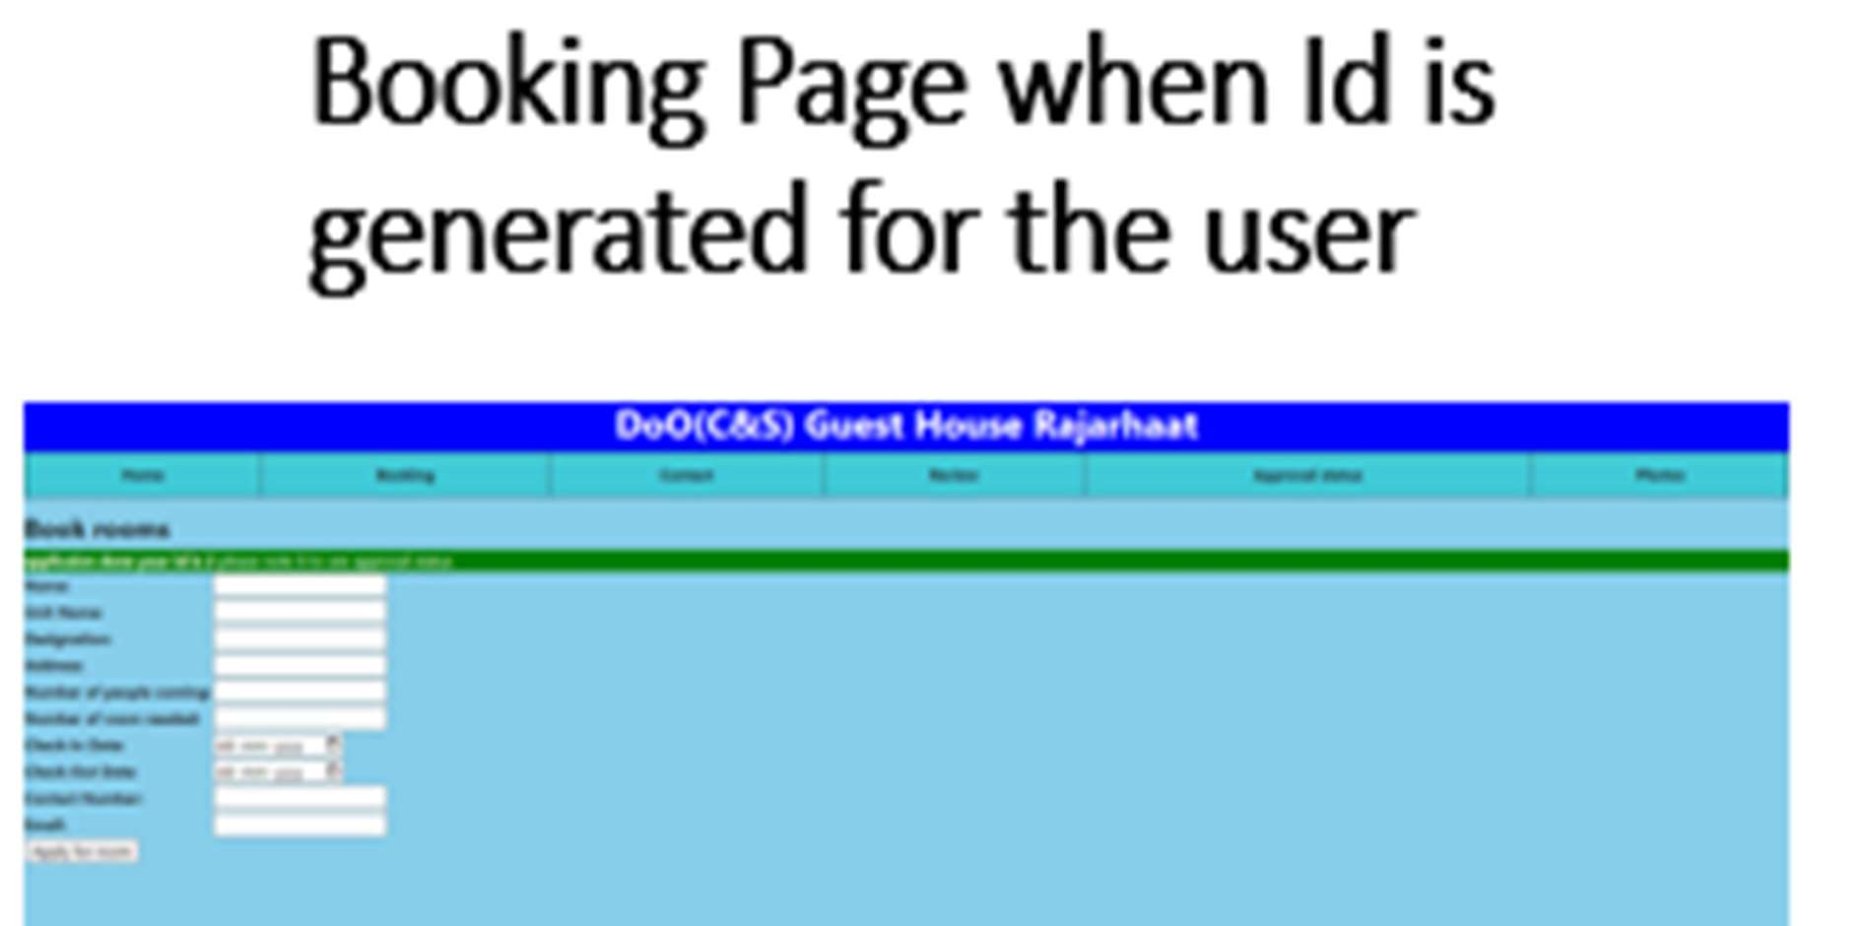

**Conclusion**

In conclusion, my internship at the Directorate of Ordnance (Coordination & Services) was an invaluable experience that significantly contributed to my professional and personal growth. Throughout my time there, I had the opportunity to work on meaningful projects, including the development of a guesthouse booking website and an in-depth report on cyber security policies. I gained hands-on experience in web development using the MVC framework and learned how to manage databases effectively with XAMPP.

Moreover, I received guidance from knowledgeable mentors and collaborated with supportive colleagues, which enhanced my confidence and skills. This internship not only deepened my understanding of cyber security and web development but also helped me build professional relationships that I will cherish in my career. I am grateful for the opportunity to contribute to such an esteemed organization and look forward to applying what I learned in my future endeavors.